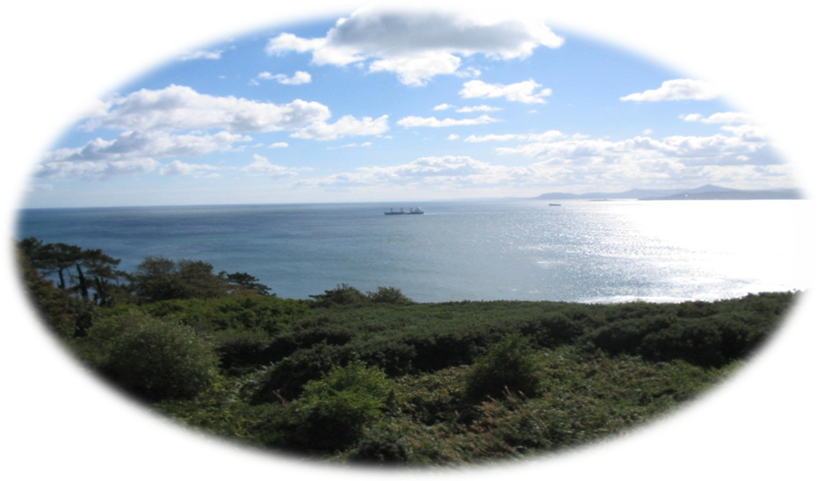
An Ashram Experience
2 Options: Residential or Day Attendance

Korko Moses a Jesuit priest from India, meditation teacher and yoga master, will lead the ashram experience

Time for: Meditation
Yoga (gentle stretches)
Spiritual direction

Time of: Silence
Simplicity
Equanimity

You are welcome for 1, 2, 3, 4 or 5 nights. Day attendees are welcome from 6.30am – 8.00pm

Where: Stella Maris Retreat Centre, Howth, Co. Dublin

When: August 27th to September 21st 2012.
Cost: €70 per day residential (includes meals)
€50 per day non-residential (includes meals)

As places are limited booking is essential and can be done through:
the Sanctuary - Email: enquiries@sanctuary.ie or Tel:+353 1 6705419
Booking form and information sheet downloadable from Sanctuary website www.sanctuary.ie
More information is available on www.sanctuary.ie and www.stellamarisretreats.ie

